Assignment 2

Q.1

Q.2

Q.3

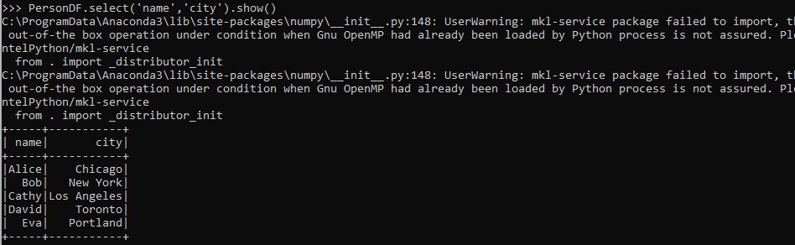

Q.4

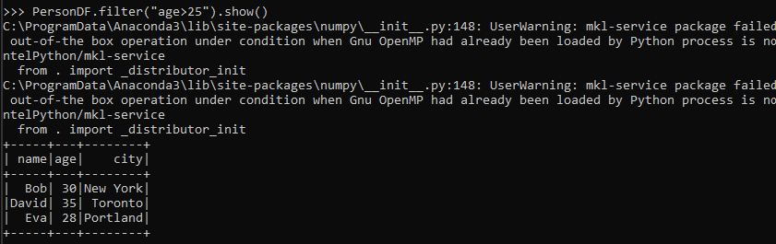

Q.5

Q.6

Q.8

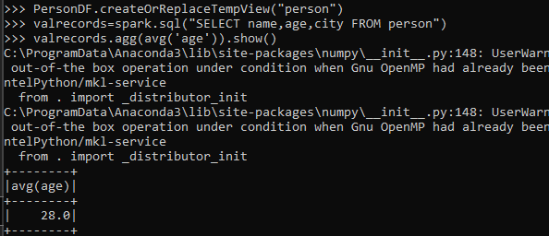

Q.9

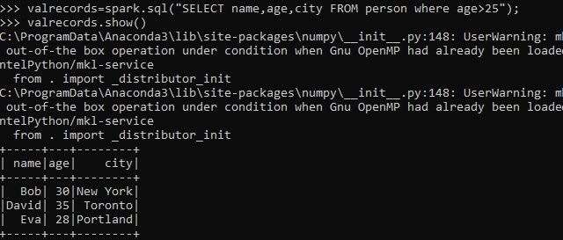

Q.10

